**Experiment-4**

**Part A**

**Aim:** Simulation of Routing Information Protocol (RIP)

**Prerequisite:** Nil

**Outcome:** To impart knowledge of Computer Networking Technology

**Theory:** The Routing Information Protocol, commonly referred to as RIP, is one of the oldest

and most basic distance-vector routing protocols used in computer networking. RIP

is primarily used for routing within small to medium-sized networks.

Here are some essential aspects of RIP:

**1) Distance-Vector Protocol:** RIP functions as a distance-vector routing protocol. In this context, "distance" denotes the count of routers (hops) between a source and its destination. Routinely, each router transmits its routing table information to its adjacent routers, facilitating the construction and upkeep of a network topology view.

**2) Hop Count Metric:** RIP employs a straightforward metric referred to as "hop count" to ascertain the optimal path towards a destination. Each hop corresponds to a single router within the route to the target. RIP routers favour paths with the least number of hops as the most favourable route.

**3) Routing Updates:** RIP routers engage in the exchange of routing updates with neighbouring routers. These updates encompass details about accessible routes and their associated hop counts. Routers utilize these updates to inform their routing decisions.

**4) Periodic Updates:** At predefined intervals, usually every 30 seconds, RIP routers dispatch routing updates. These periodic updates aid routers in adapting to alterations within the network, such as link failures or changes in network topology.

**5) Preventing Loops:** RIP employs mechanisms like "Route Poisoning" and "Split Horizon" to forestall routing loops. Route Poisoning entails advertising unreachable routes with an infinite hop count, while Split Horizon prevents a router from disseminating routes back to the router from which it was learned.

**6) Convergence Time:** RIP may require a period to converge, following network alterations. During this convergence phase, routing information remains in flux, and less-than-optimal routes may be used until the network achieves stability.

**7) Scalability Constraints:** RIP exhibits limitations regarding scalability. It may not be well-suited for extensive or intricate networks since it relies on periodic updates and possesses a restricted hop count metric.

**8) Multiple Versions:** Two principal versions of RIP exist: RIP-1 and RIP-2. RIP-2 extends RIP-1 and encompasses features such as variable-length subnet masking (VLSM) and authentication, which are absent in the original RIP-1.

Despite its simplicity in configuration and comprehension, RIP has several drawbacks, including sluggish convergence and a limited understanding of network topology. Consequently, it is less frequently employed in contemporary networks, particularly in expansive or intricate environments. More advanced routing protocols like OSPF (Open Shortest Path First) and BGP (Border Gateway Protocol) are frequently favoured for their heightened flexibility and scalability.

**Procedure:**

1. Open Cisco Packet Tracer and simulate the sample topologies for RIP.

2. Perform Necessary Operation on Switch to create and configure RIP.

3. Check the connectivity between the devices.

**Part – B**

**Steps:**

1. Open Cisco Packet racer and simulate the sample topologies for RIP.

2. Perform Necessary Operation on Switch to create and configure RIP.

3. Check the connectivity between the devices.

**Output:**

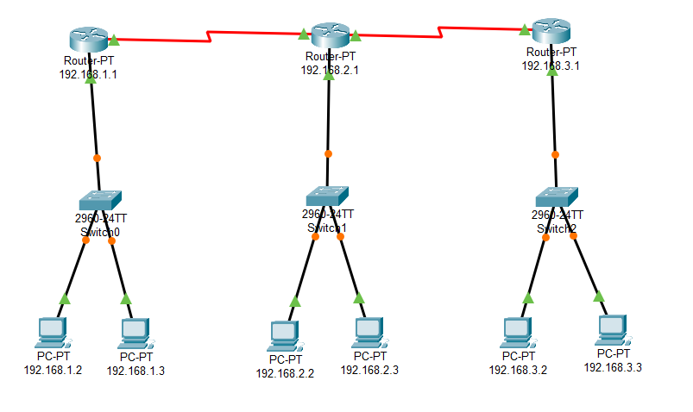

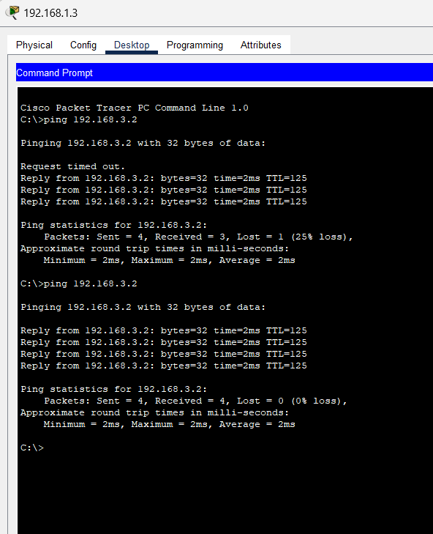

**Observation & Learning:**

Using Cisco Packet Tracer for router simulations, I gained practical insights into configuring routers, setting IP addresses, enabling inter-router communication, troubleshooting, and optimizing network performance. This hands-on experience highlighted the importance of proper configuration and routing protocols for efficient data transmission—an essential skill for network administrators and engineers.

**Conclusion:**

In summary, the Cisco Packet Tracer router simulations provided valuable learning experiences in network configuration and management. They emphasized the crucial role of routers in directing data traffic, securing networks, and enabling efficient communication. This practical experience equipped me with essential skills for real-world network setups, highlighting the significance of accurate configuration and troubleshooting for robust and reliable networks.

**Questions:**

**1. What type of port are used for the connection between the routers?**

**Ans:** Routers employ a diverse set of ports. Below are some typical ports commonly used for inter-router connections:

**1) Ethernet Ports (RJ-45):** Routers often connect to each other and other networking devices using Ethernet ports. These ports use the Ethernet protocol to transmit data over wired connections. Ethernet cables, typically with RJ-45 connectors, are commonly used to interconnect routers within a local area network (LAN).

**2) Serial Ports:** In some cases, especially in older router models, serial ports (like RS-232 or RS-485) might be used for router-to-router connections, particularly for wide-area network (WAN) connections.

**3) Fiber Optic Ports:** In situations where high-speed and long-distance connections are required, routers may have fibre optic ports for connecting via optical cables. These ports can support various fibre optic standards like SFP (Small Form-Factor Pluggable) or SFP+ for higher speeds.

The choice of port and connection speed depends on the specific networking needs, the router models being used, and the available infrastructure. Modern routers often have a mix of Ethernet ports to accommodate various networking scenarios.

**2. How RIP ensure about the path from source to destination?**

**Ans:** RIP (Routing Information Protocol) does not ensure the path from source to destination in the same way some other routing protocols do, such as OSPF or BGP. RIP is a simple distance-vector routing protocol primarily focused on determining the shortest path to a destination network based on hop count. While RIP can find a path to a destination, it has limitations that affect its ability to guarantee optimal or reliable paths:

**1) Hop Count Metric:** RIP uses the number of hops (i.e., the number of routers a packet must traverse) as its metric for path selection. It does not consider factors like link bandwidth, latency, or network congestion. Therefore, RIP's path selection is solely based on hop count, which may not always represent the best path in terms of performance or reliability.

**2) Limited Metric Values:** RIP uses a maximum hop count value of 15. If a route's hop count exceeds this limit, it is considered unreachable. This limitation can cause problems in larger networks, as routes that are more than 15 hops away are effectively unreachable, even if they are technically reachable through a longer path.

**3) Convergence Time:** RIP relies on periodic updates to exchange routing information between routers. When network topology changes occur (e.g., a link goes down), it can take some time for RIP routers to converge and update their routing tables. During this convergence time, suboptimal routes may be used.

**4) Split Horizon:** RIP uses a technique called "split horizon" to prevent routing loops. While this helps prevent routing loops, it can also result in suboptimal routing in some scenarios, especially when there are redundant links in the network.

**5) Limited Scalability:** RIP may not scale well in large and complex networks due to the frequent exchange of routing updates and the hop count limitations.

**6) No Load Balancing:** RIP does not support load balancing across multiple paths to the same destination. It always selects a single best path based on hop count.

In summary, RIP's primary goal is to find the shortest path to a destination based on hop count, but it lacks the sophistication and flexibility of more advanced routing protocols. It does not guarantee the best path in terms of performance or reliability, and its operation is limited by its hop count metric and periodic updates. For more robust and flexible routing, especially in larger and more complex networks, network administrators often choose routing protocols like OSPF or BGP, which offer better control and optimization of routing paths.

**3. What is the importance of gateway addresses?**

**Ans:** Gateway addresses, often referred to as default gateways or routers, play a crucial role in computer networking and are of great importance. Here's why gateway addresses are significant:

**1) Packet Routing:** The primary role of a gateway address is to route data packets between different networks or subnetworks. When a device on a local network wants to communicate with a device on another network (e.g., the internet or another LAN), it sends its data packets to the gateway. The gateway then forwards these packets to the appropriate destination network, either locally or through other routers.

**2) Internet Connectivity:** In most home and small business networks, the gateway address is the device responsible for connecting the local network to the internet. This allows devices within the local network to access resources and services on the global internet. Without a gateway address, local devices would be unable to communicate beyond their own network.

**3) Network Segmentation:** In larger networks, gateways are used to segment the network into different subnetworks or VLANs (Virtual LANs). Each subnetwork has its gateway address, and gateways manage traffic between these segments. This segmentation enhances network security, isolates broadcast domains, and allows for better traffic management.

**4) Routing Decisions:** Gateways make routing decisions based on the destination IP address of the packets they receive. They consult their routing tables to determine the best path for forwarding packets to the desired destination. Gateways use routing protocols or static routes to populate their routing tables with this information.

**5) Security:** Gateways often include firewall functionality, allowing them to filter and control traffic entering and leaving the network. They can block or permit traffic based on specific rules and policies, enhancing network security.

**6) Network Address Translation (NAT):** Gateways frequently perform Network Address Translation, which allows multiple devices within a local network to share a single public IP address when accessing the internet. NAT helps conserve public IP addresses and adds a layer of security by hiding internal network addresses.

**7) Failover and Redundancy:** In redundant network setups, multiple gateways may be configured to provide failover capabilities. If one gateway becomes unavailable, the traffic can be automatically redirected through an alternative gateway to ensure network continuity.

The gateway address holds significant importance in networking as it serves as a vital link enabling communication between local networks and external networks, including the internet. This critical component facilitates routing, enhances security, supports network segmentation, and enables multiple devices to share a single public IP address through Network Address Translation (NAT). A properly configured gateway address is indispensable because, without it, devices within a local network would remain isolated, unable to access resources or services beyond the confines of their own network.